**Coconut Market Update - June 2021**

General Overview

Following our last report in March the market has predictably firmed due to increasing demand in a world where some economies, such as the USA and UK, are bouncing back fast posting high growth forecasts for the balance of 2021. Supply from the main origins has deteriorated and freight has unbelievably increased yet again. In June we saw levels move from $12,500 to over $14,500 for a 40’ FCL. Logistical lead times have increased over recent weeks as UK port congestion coupled with container availability in Asia has slipped back, and we are not even in peak season yet so there is worse to follow.

Other news in brief

* Supply from our major suppliers is on allocation, we do not have enough for everybody, so we have been actively out there trying to bring in new origins and supply sources.
* First Grade has come up with alternative options to keep customers in supply and help fight the price increases so please speak to your account manager to understand more.
* Looking for cost saving initiatives on coconut milk and cream? Speak to your account manager for details of our new product launches.

Global Demand

Foodservice is open again in the UK, USA and some European countries. Demand as a result is more than outstripping supply just now. We even have enquiries from China looking for 1000 tonnes of coconut cream, just to highlight the current shortage. We are hearing about discounters in Germany and across Europe being out of stock of canned coconut milk. Empty spaces on supermarket shelves across the UK certainly seem to be becoming more frequent as supplies just cannot get here in time.

Coconut Oil price tracking

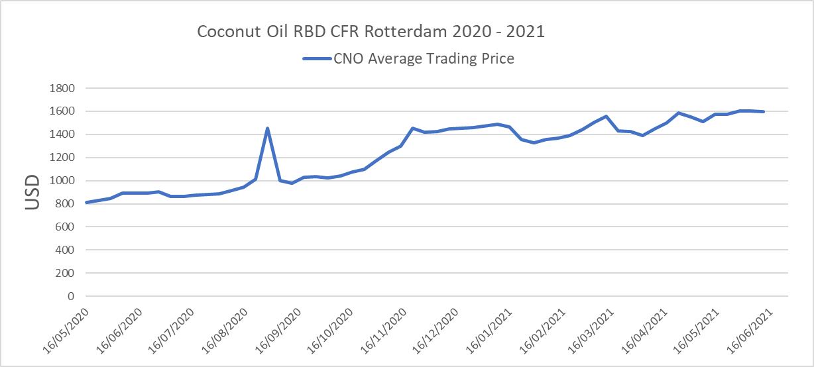

Currency Watch

A strengthening dollar.

Interest rates in America look set to rise in 2022 due to a faster than expected recovery following the Covid 19 vaccination programme. Thankfully, the pound is on a similar trajectory with strong growth this year on the Covid rebound and increasing interest rates forecasted for 2022.

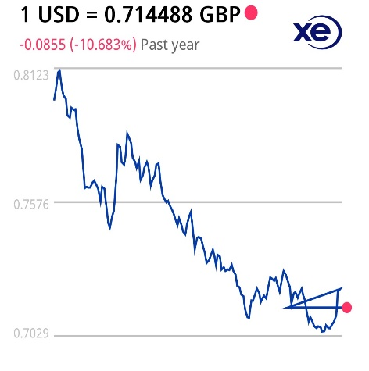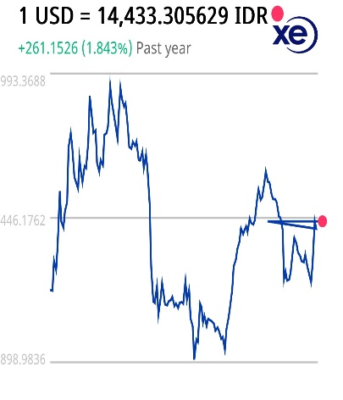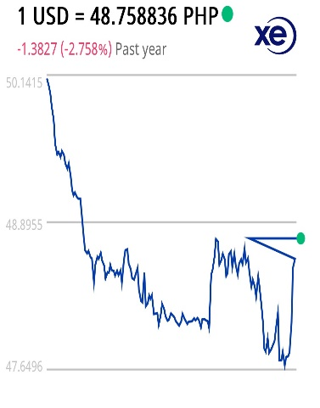

Logistics Update

Why are importing companies like First Grade running low on supplies?

* Suppliers are shipping late due to Covid restrictions and outbreaks are affecting workforce as well as output.
* Once goods are available for shipment it can take two to four weeks to obtain an empty shipping container, load the product and get it to the port (Previously one week).
* Voyage time from Asia is typically 30 days but, due to UK port congestion, shipping lines now advise us with just 24 hours’ notice as the vessel nears the UK waters that they may miss out unloading in the UK altogether. The ships then continue their voyage around Europe, not to returning for a further two weeks, consequently taking the voyage time to 44 days (we have seen some even take 60).
* Once the vessel does arrive at the UK port whereas we used to expect unloading within 48 hours this can now be as long as 4-5 days.
* Moving goods from the port to our store is troublesome because of the national driver shortage along with shipping lines regularly cancelling bookings due to lack of personnel. We previously allowed 5 days and now must allow 14 for this transit time.
* All in all, shipping time has been extended by 8 weeks which depletes our buffer stocks in a time when suppliers are already reducing allocation. To rebuild buffer stocks we need suppliers to increase allocation, therefore in the meantime we have to look for alternative sources in some instances just to keep supplies going.
* Current high freight rates look set to continue until at least 2023.

Update by Origin

Indonesia:

We are keeping a close eye on this origin following the mass migration that took place in May and June, following Ramadan, where millions of workers across the islands returned home to see families back in the rural areas across the different provinces. Having seen the results of such mixing in India over recent months it is very concerning, but as yet too early to comment. Offers from DC shippers are in small volume and intermittent on a nearby basis with many mills sold out for July as well as August. Price levels are still below Philippine as is the norm due to a general lower quality, high micro product and we expect this to continue as we go into the second half of the year. Markets which generally buy this quality are also still on the low demand side due to Covid which is keeping levels from spiralling too fast.

Sri Lanka:

Some respite came for the coconut exporters which was not expected as the lockdown in Sri Lanka had continued subduing the foodservice sector. This meant domestic market demand for coconut oil (200,000 tonnes per annum) was much lower than anticipated leaving some raw materials spare for DC processors. With a slight dip in pricing, albeit still much higher than Philippine, shippers were able to make contracts on a prompt basis for customers who could not cover from usual sources in the Philippines. As a result, there has been some brisk trade of late simply because it has been the only origin offering product on a prompt basis. This will come to an end in September as the summer season comes to an end and nut supply dwindles again.

Philippines:

Following our last report in March the Philippines entered an intense period of high Covid cases into April, meaning many April shipments did not take place. The rollover of these shipments has meant many Q2 orders now need to be fulfilled in Q3 therefore reducing the volumes available for Q3 purchase. With a reduced offering generally across the whole of the Philippines in Q3 we have seen levels spike again as supply was even less than Q2. This is in a global market where demand had already started to increase particularly in America, which is a strong export market for the Philippines.

 Update

* NCR Plus which includes Metro Manila and Laguna are now under General Community quarantine until June 15 as there have been observed downward trend in cases from the surge that was experienced end March 2021. Head Office remains on Work-from-Home scheme.
* Davao City which is close to Davao del Sur had been placed under Modified Enhanced Community Quarantine until end of June as there is an observed increase in number of cases starting last week.
* Government agencies continue to work on compressed schedule affecting processing of shipment documents.
* All plants remain operational but are still experiencing operational issues related to the on-going pandemic situation.
* There are more frequent deliveries of vaccines to the Philippines in the past days and roll out now includes personnel under the A4 category – economic front liners



* Warehouse utilization are at its highest as challenges on securing booking confirmation and tight vessel space persist. Customers are advised to book shipments a month in advance for higher probability of space availability.
* Vessel backlogs and congestion at US West Coast Ports continue to persist. The ports of LA and LB remain strained with vessel wait times averaging between 1 to 2 weeks, while Port of Oakland waiting time is now extended to 3 weeks.
* Traditional Peak Season for maritime shipping is in August and September but expected to start earlier than usual.
* True recovery in Europe has not yet happened and the strong demand in the Asia-Europe trade is expected over the next few months.
* European importers are now focusing on building up inventories. Also, they are saying that there are billions of Euros in bank accounts ready for consumption.
* To compensate for port delays and preserve schedule reliability, carriers are planning to cancel some sailings and skip some ports, hence issue of tight space will continue to worsen as demand grows.
* Spot rates for Asia-North Europe trade was up 495% according to data from benchmarking platform Xeneta.
* As of May 2021, global average shipping rates was up 400% over last year’s rate.
* Global supply chain will remain unreliable and shipping rates will remain high for the rest of the year.



* On June 4, 2021, Philippine Atmospheric Geophysical and Astronomical Services Administration (PAG-ASA) have officially declared the start of the rainy season, expected to bring increased rainfall throughout the country.
* The occurrence of heavy rainfalls such as that expected last week when Typhoon Choi-wan made landfall in the Philippines results to a lower manpower fill rate and eventually reducing the number of operating lines.
* This season can also impact raw material prices especially if there are major typhoons which will hit the country. A news article* indicated that PAG-ASA is estimating an average of two tropical cyclones every month until end of the year.